Access Control System

Access Control System, built with Odoo 16 community version, is used to authorize employees at entrance gate where the user (guard) can open the website in browser and have access to page where they can scan barcodes of employee cards and the system will see if such employee with given barcode exists in the database. Employees who have correct barcode will be granted access but the same will not happen for those who do not have access right.

1. System Access Rights: There are two access rights in the given system:

administrator and user as seen in the picture:  
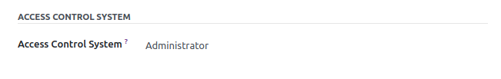

* Administrator: has full access and can edit, delete, create and read employees’ records.
* User: Only has read access to employees’ records.

2. System UI: the system has list view of all employees saved and has button to create a new employee as shown  
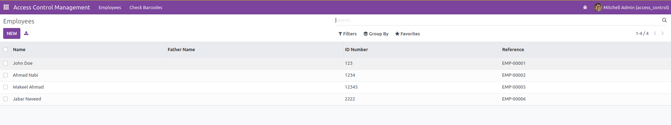

Employee record can be expanded in a form view by clicking on any employee:  
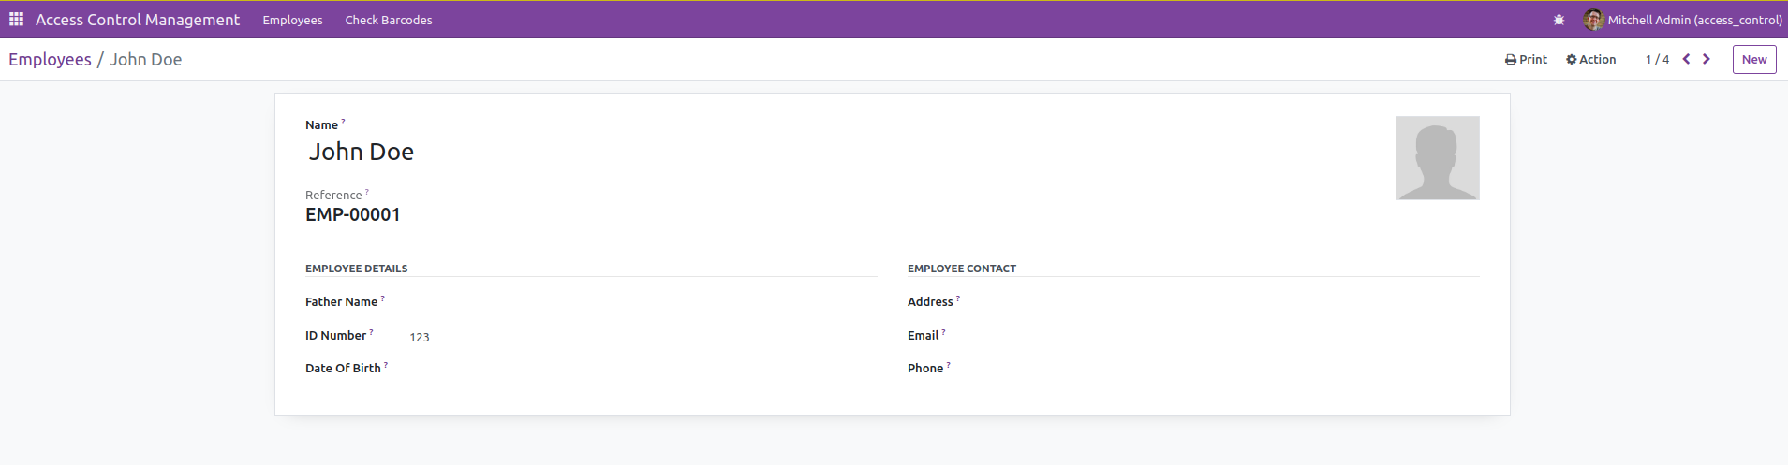

3. Employee Card: system can generate PDF format of employee data as card by clicking on the print option on the top right corner and this option will print a card in the format of PDF:  
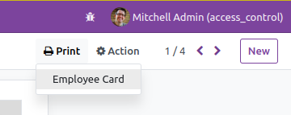

After clicking on the employee card, a card with barcode will be printed which can be scanned at the gate. Example of the card:  
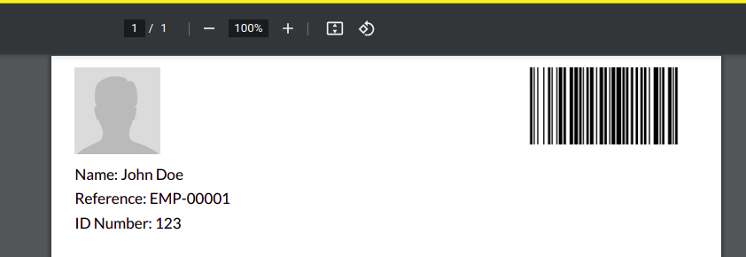

4. Barcode Checking: a link to page called barcode checking is given where the user has an input and a button to validate a scanned barcode value in the input field:  
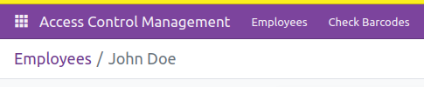

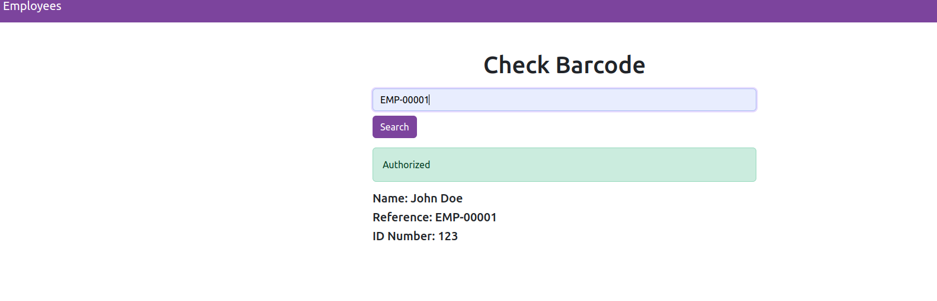

After 5 seconds the result will disappear.   
